**Guide to make use of 3D Zephyr**

**Installation:**

1. **Go to -** [**https://www.3dflow.net/3df-zephyr-photogrammetry-software/**](https://www.3dflow.net/3df-zephyr-photogrammetry-software/)
2. **Click on Try 3DF Zephyr. Note- There is a free version as well which can work but has limit of 50 images.**

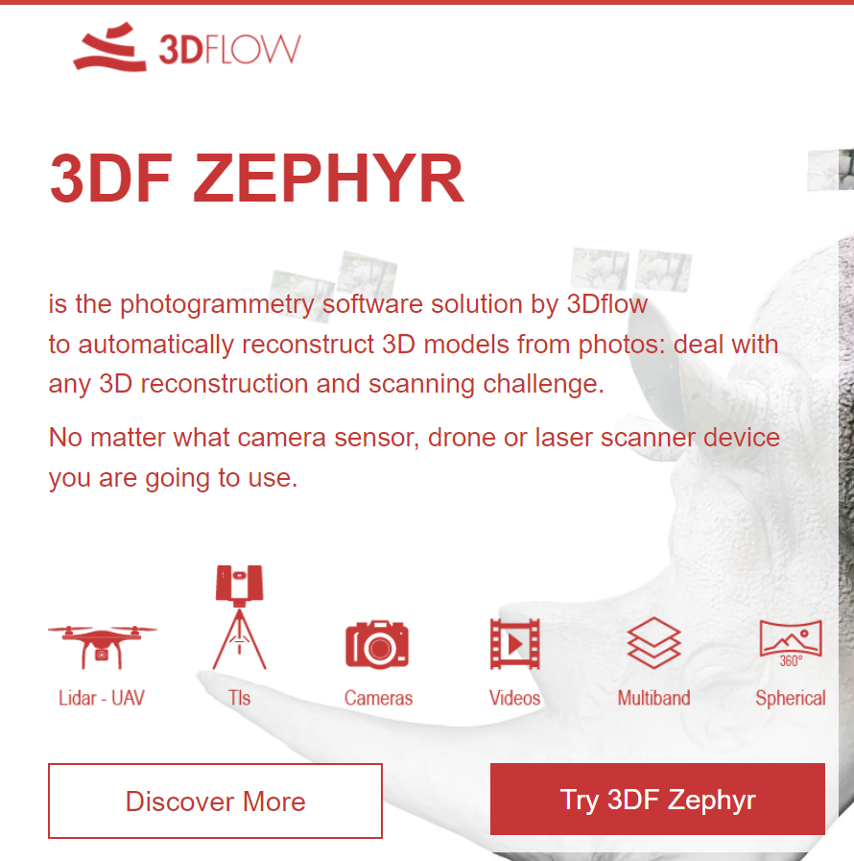

1. **Provide the information (you can use Trinity ID for this)**

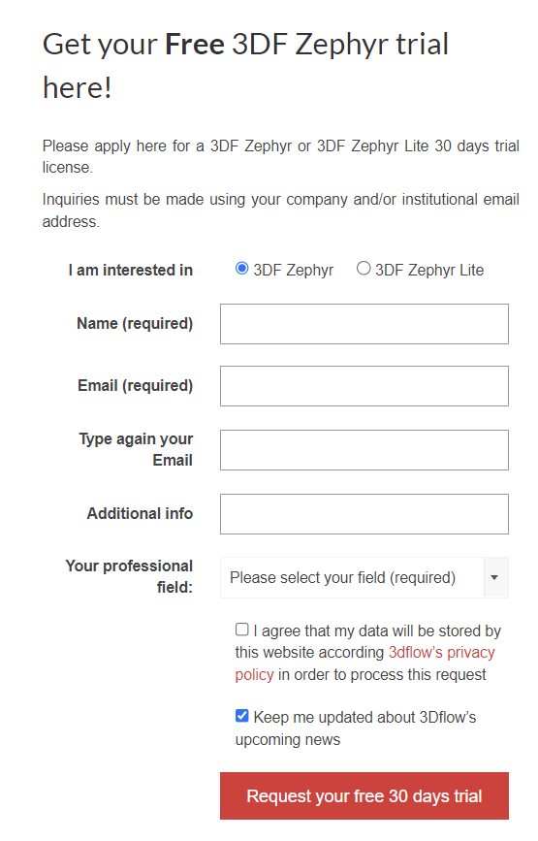

1. **Install the software through .exe file and you can use the Key you receive in the mail to activate the trial of the software.**
2. **Once done, here’s how the UI would look like:**

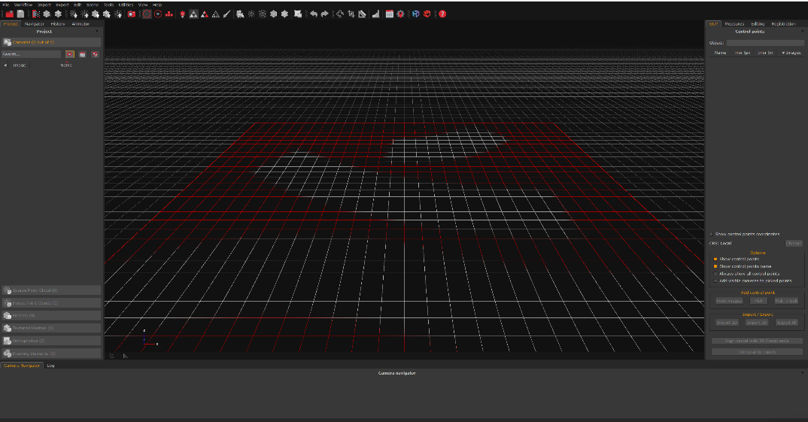

1. **Click on New Project icon:**

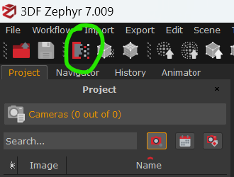

1. 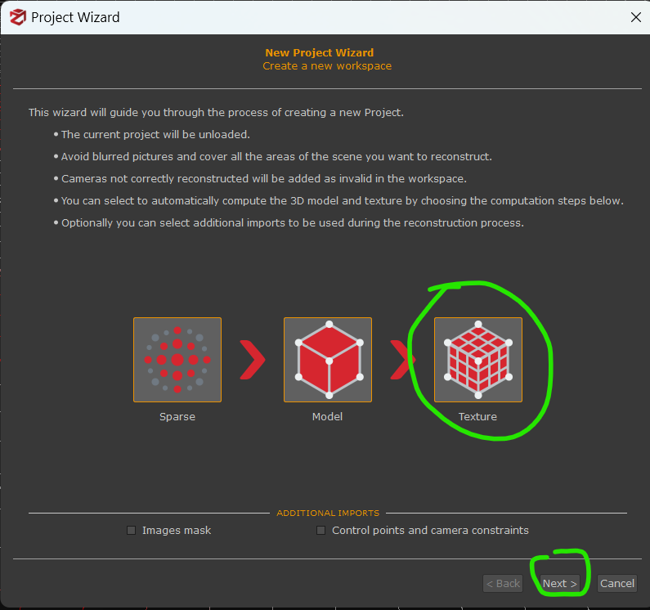**Click on Texture. This will make the software do the whole thing end to end. And click on Next**
2. **Click on Add Images icon- Plus sign red icon. You can even import a video rather. lick on next.**

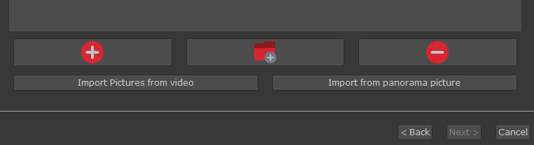

1. **It will hopefully be able to caliberate the information about camera etc using EXIF in images. In case it’s not able to, same trick that we used for Meshroom might work here. Click on next.**

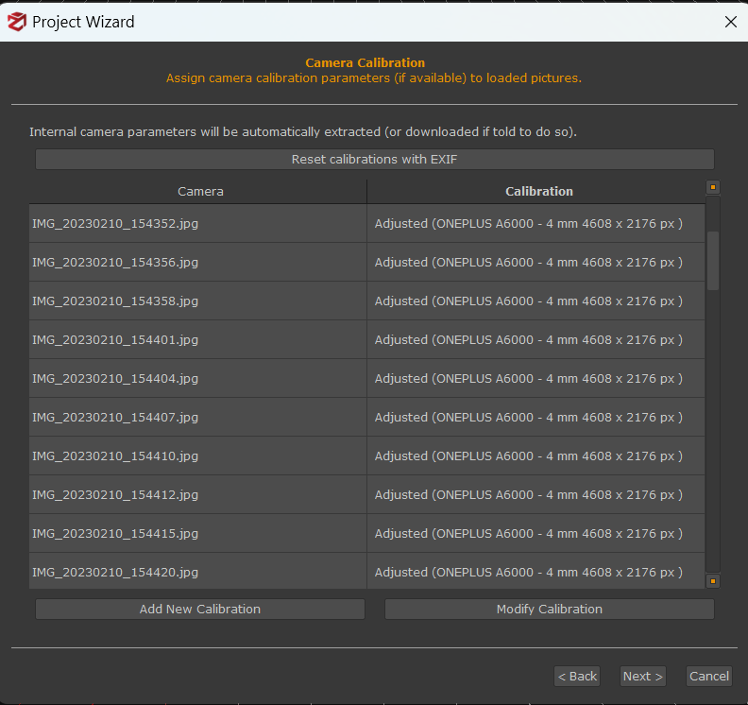

1. **Zephyr allows three modes, you can either use presets, or you can get more advanced options or you can go on and completely customize your workflow. The customized option gives lot more detailed choices. We will go with preset for now.**

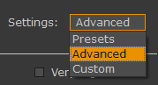

1. **Going with General Category and Fast Preset.**

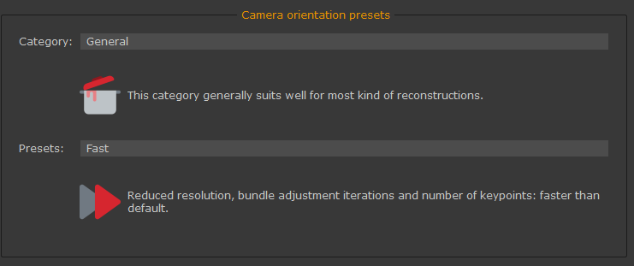

1. 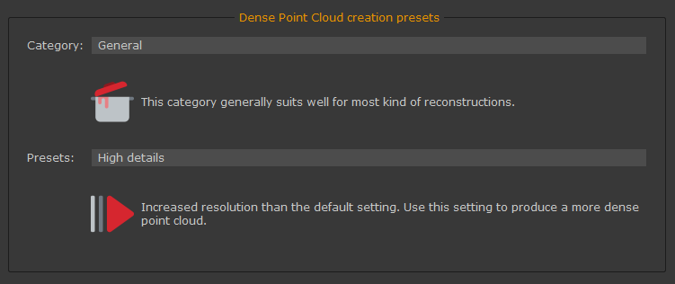**For Dense Point cloud, we will again choose General and High Details in Presets**
2. **And choose same for Surface reconstruction and Texture preset.**
3. **It will then show the final session session and you can at the top click on Run.**

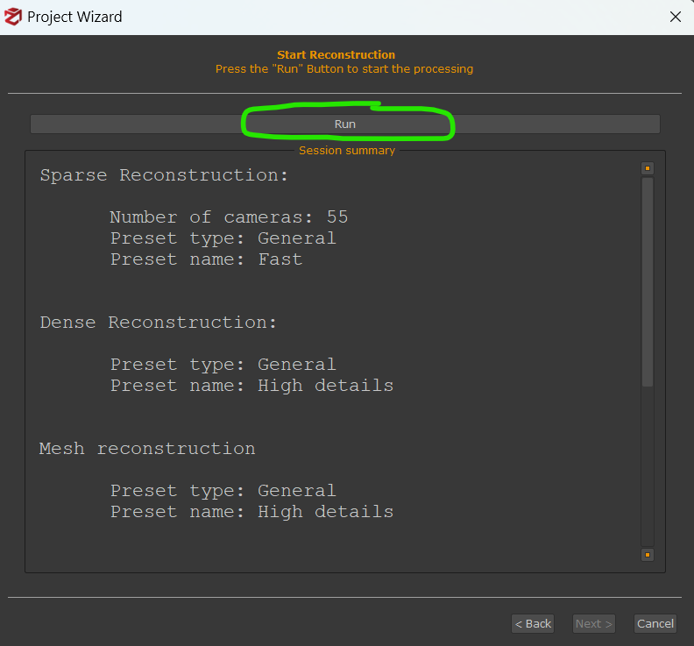

1. **While the process is running, you can even check the log and system info:**

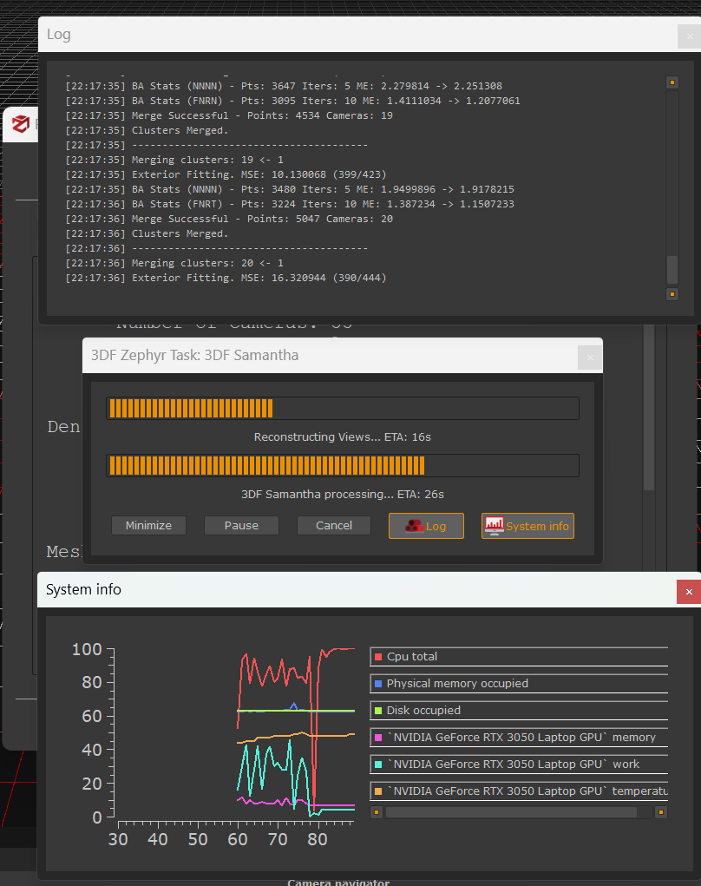

1. 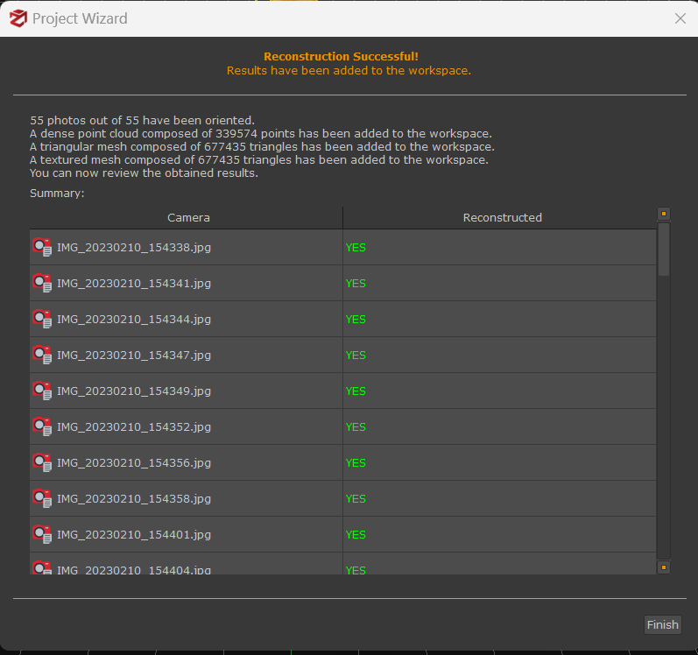**Once finished, it will show which images were good and actually used:**
2. **Click on Finish and you’ll have the final model at the background.**

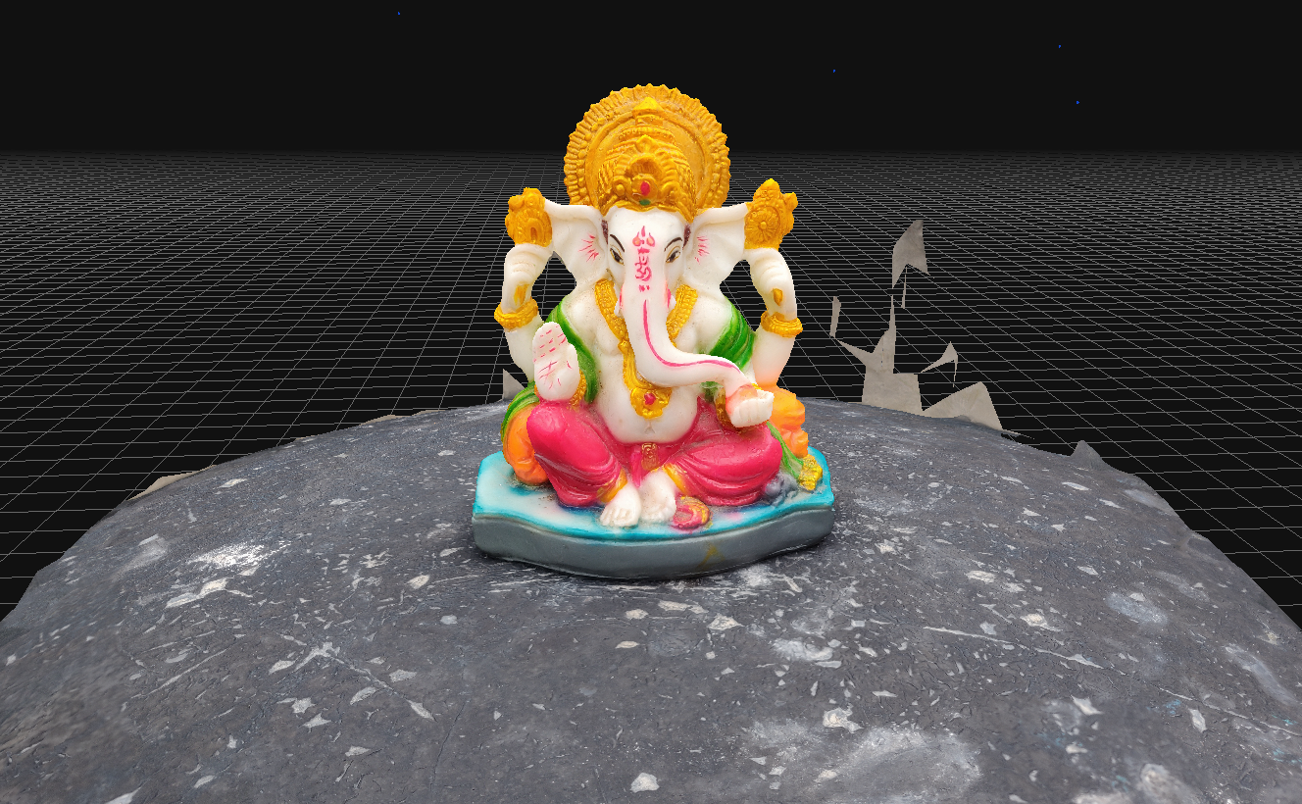

1. 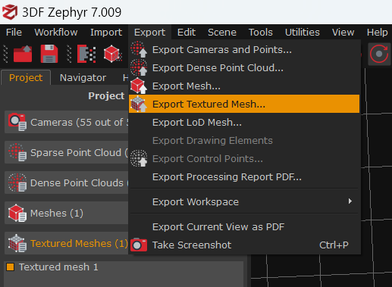**Click on Export and Export the Textured Mesh**
2. **Do remember to click on Export as single texture, choose your format and just export**

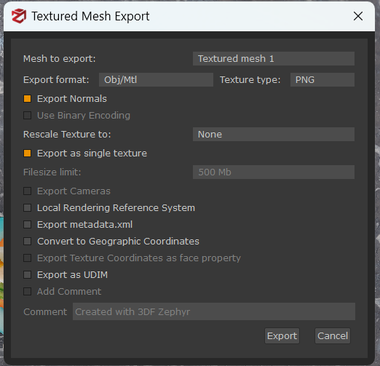

1. **Rest of the cleaning the model part is same as we did in case of Meshroom in Blender**